Azure Governance Hack

Objective:

* Build a governance strategy using Management Groups, Azure Policy, and Blueprints
* Group and organize your subscriptions in a logical hierarchy that support the deployment of other Governance services in a structured way

The topics covered are:

* Subscriptions and Portals
* Resource Locks and RBAC
* Management Groups
* Azure Policy
* Blueprints
* Resource Graph

1. **Prepare Environment**
   * Create a new AD Tenant
   * Create Azure Subscription
   * Deploy environment using ARM templates (The template I am currently using is a DC with 2 VMs and using unmanaged disk. The hack has a policy to identify VMs with unmanaged disk)
2. **Management Groups**: The very first step in implementing a governance strategy in Azure is to create a **logical hierarchy in Management Groups**

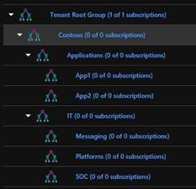

1. **Policies**:
   * Use out of the box policy to identify virtual machines that aren't using managed disks. At the end of this process, you'll successfully identify virtual machines that aren't using managed disks. They're non-compliant with the policy assignment.
   * Implement a new custom policy to not allow/Deny certain VM SKUs
2. **Blueprints:** The blueprint should do the following:
   * RBAC-Contribute permissions to Security Compliance group to all environment/Subscription under Contoso Management Group. The user/group should be a parameter that allows values during the blueprint assignment.
   * Required Tagging for every resource group with CostCenter. The value of the Tag should be a parameter that allows values during the blueprint assignment.
   * There should be a new Resource Group and a Storage Blob created in the scope where the BluePrint is assigned.
   * RBAC Contributor role assigned to the business lead for Resource Group
   * Create a new version of blueprint with some modifications

My final Blueprint looked like this:

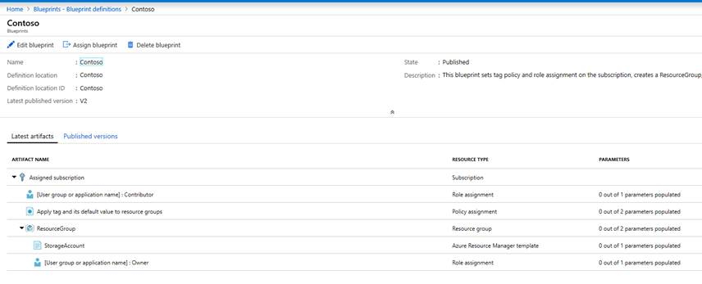

1. **Resource Graph:** Monitor and review all resources deployed through Resource Graph

CloudShell Azure CLI:

* List resources sorted by name
* Virtual machines by SKU
* Count Azure resources

**Azure Cost Management**